**Meshack Mumo Mutisya.**

**Cyber Security.**

**Online class.**

**Who.is info on twitter and Facebook.**

**Twitter.**

Here we see the domain information about twitter.

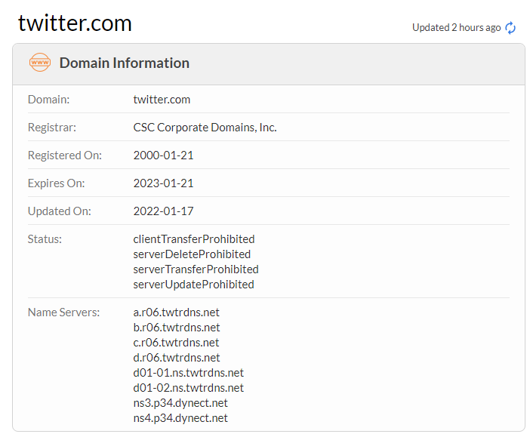

Here, the registrant contact information is shown

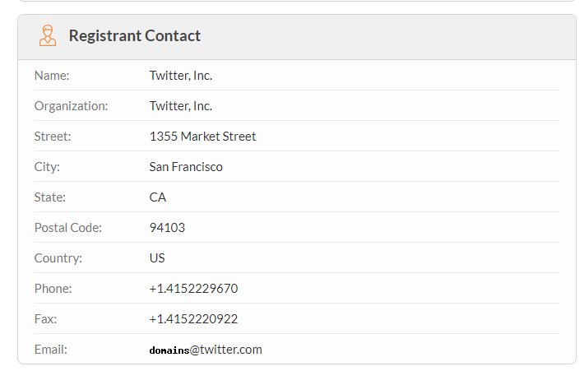

Here, the administrative contact information is shown.

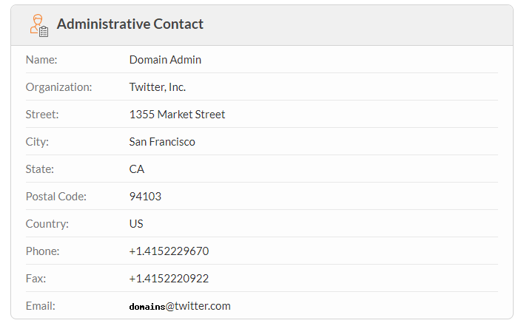

Here, the raw data about twitter.com is shown

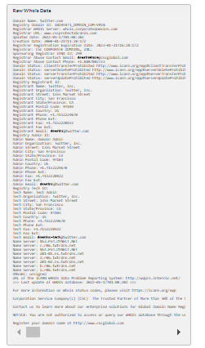

**Facebook**

Here we see the domain information about facebook.

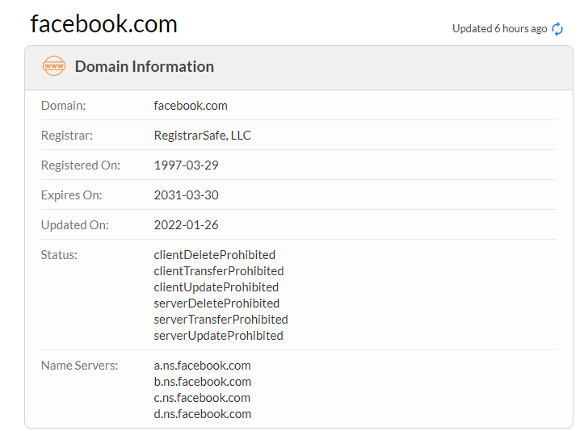

Here, the registrant contact information is shown

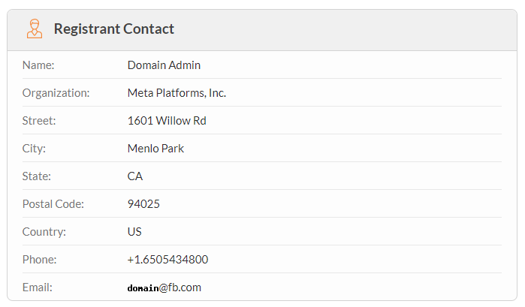

Here, the administrative contact information is shown.

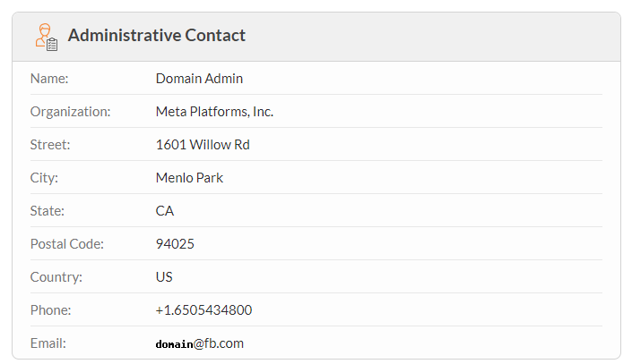

Here, the raw data about facebook.com is shown

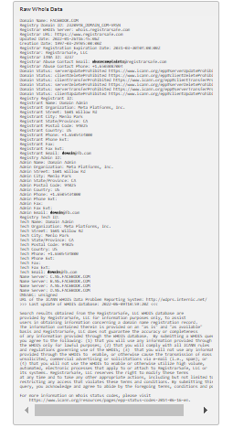

**Wayback info on twitter and Facebook.**

**Twitter**

Twitter in 2001.

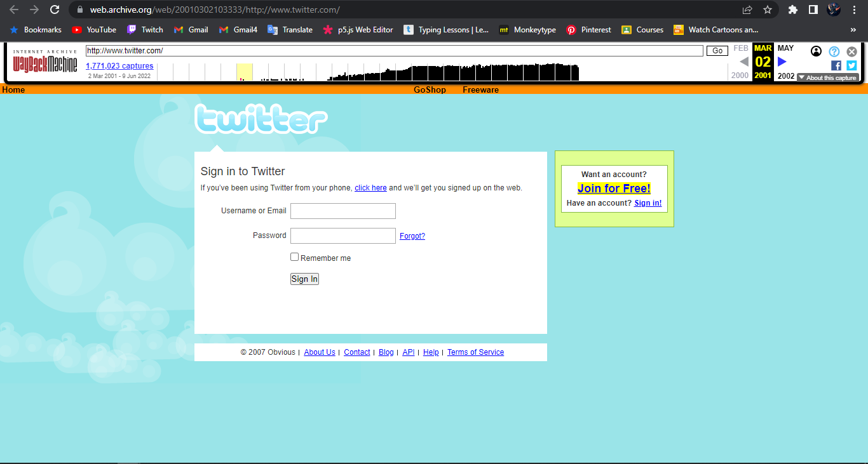

Twitter in 2002.

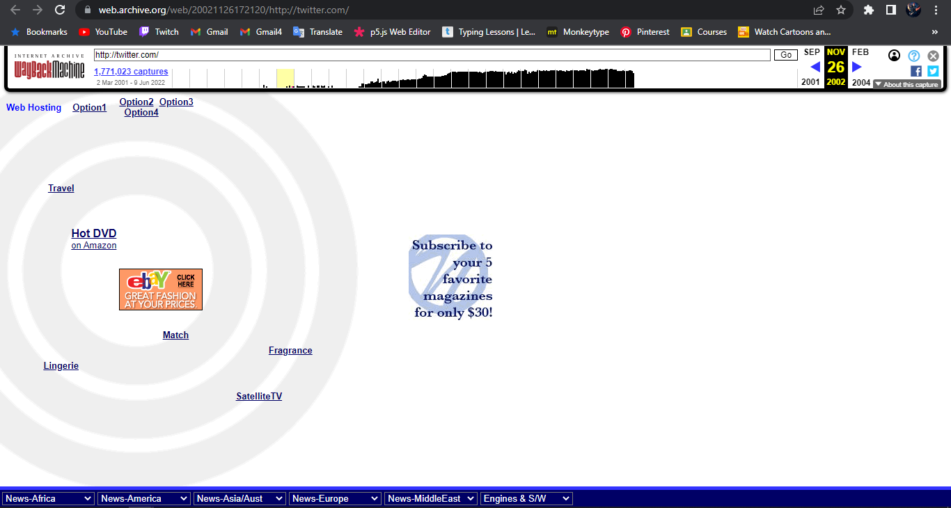

Twitter in 2003.

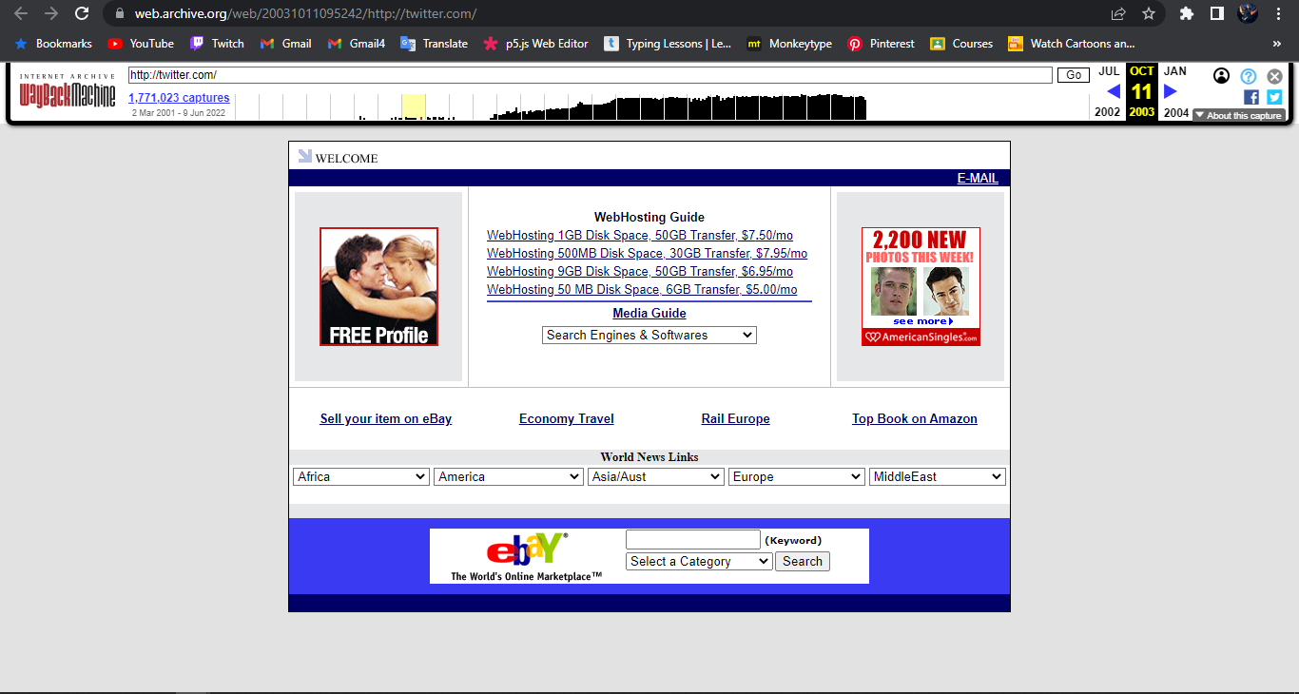

Twitter in 2004.

At this stage, twitter was on sale to the public.

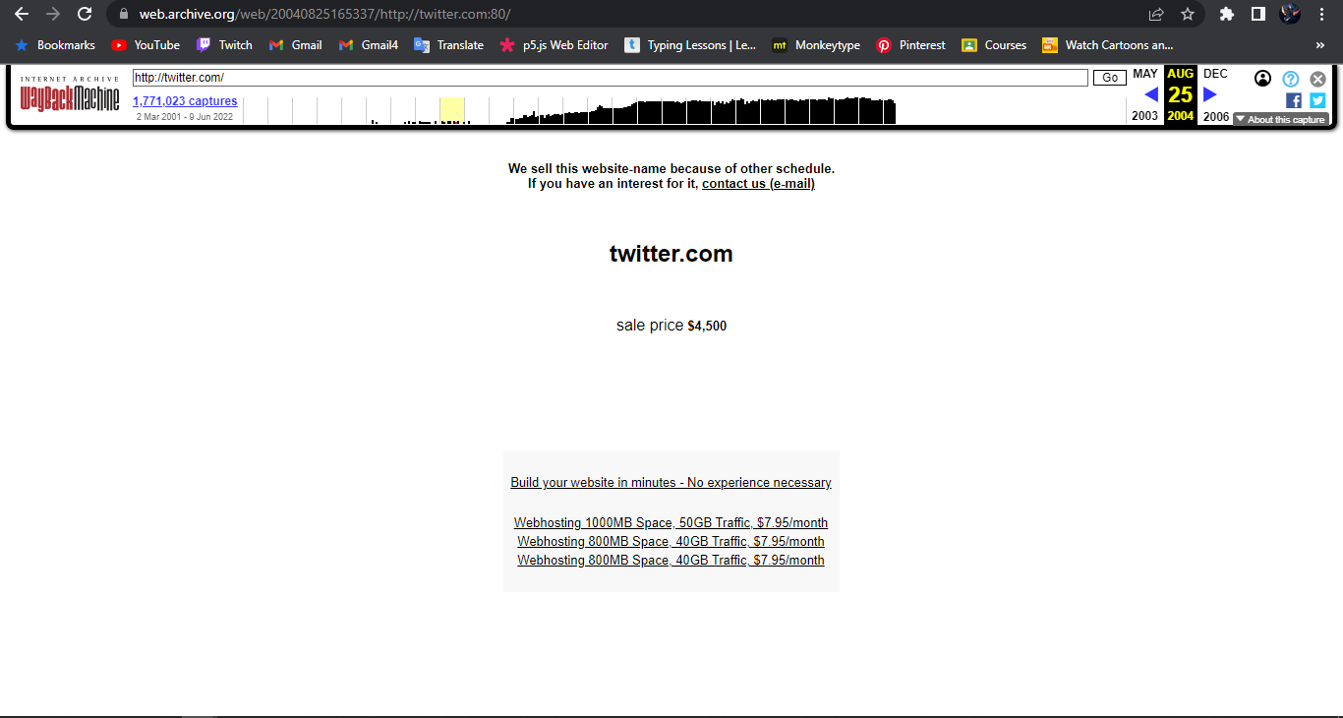

Twitter today.

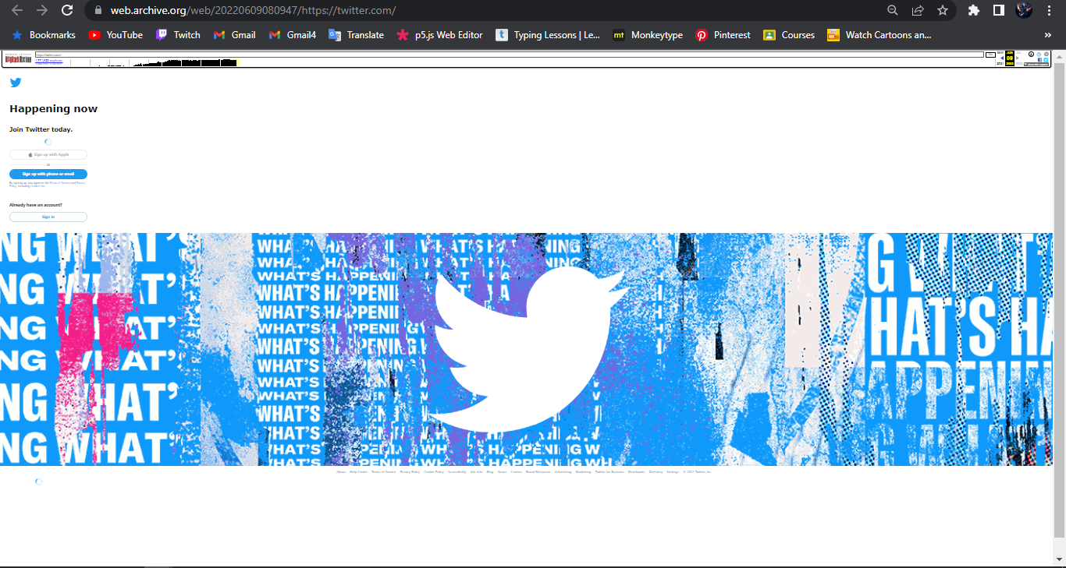

Twitter has greatly changed since its launch and greatly updated its patches.

From 2001, we can see that the updates that have been done on twitter.com are for the better of its users.

**Facebook**

Facebook in 2001.

Facebook was invented in 2004, anything before then will show the page below.

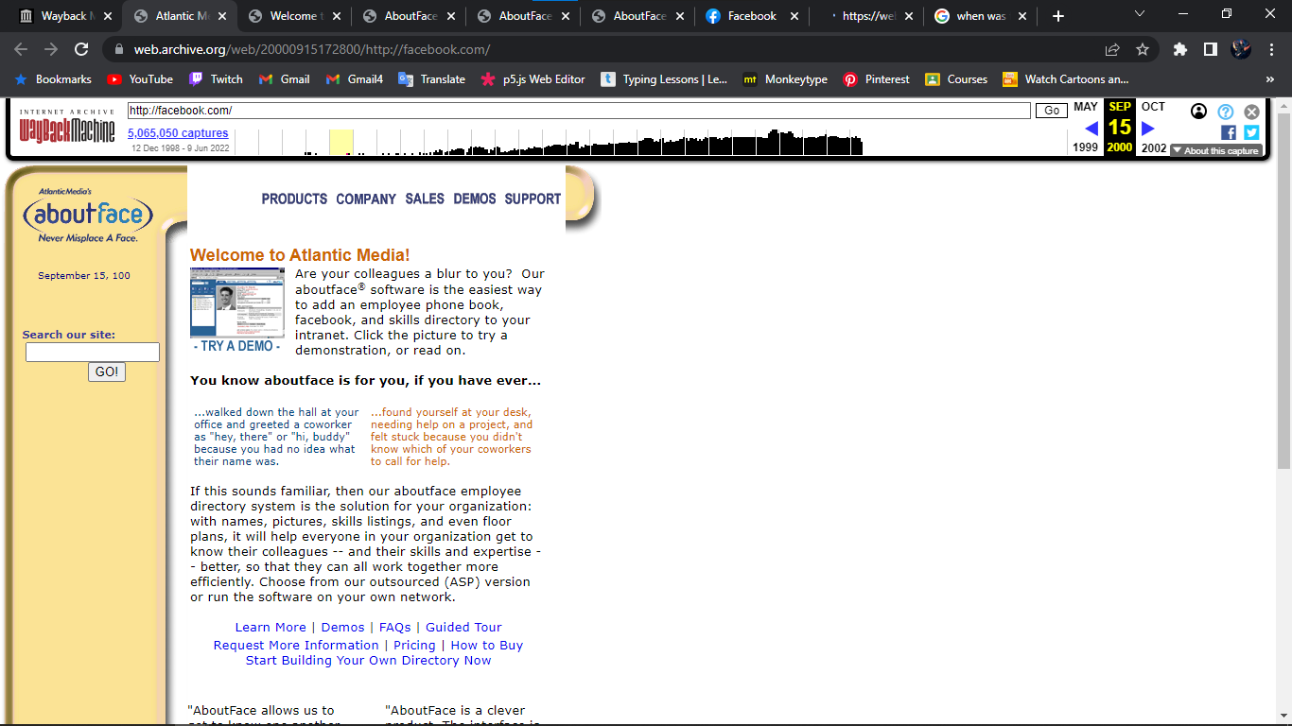

Facebook in 2005.

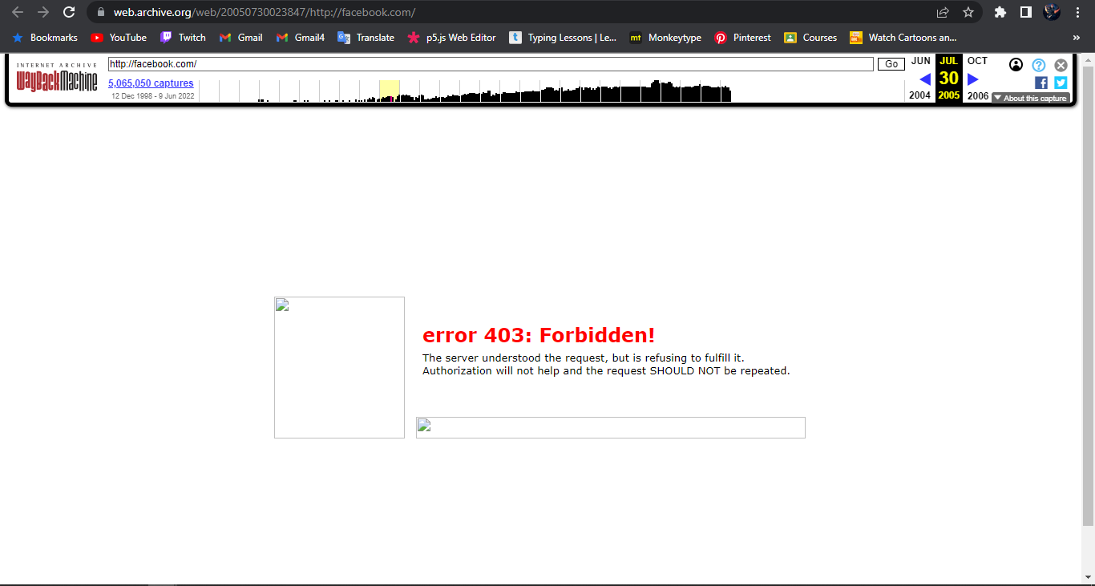

Facebook in 2006.

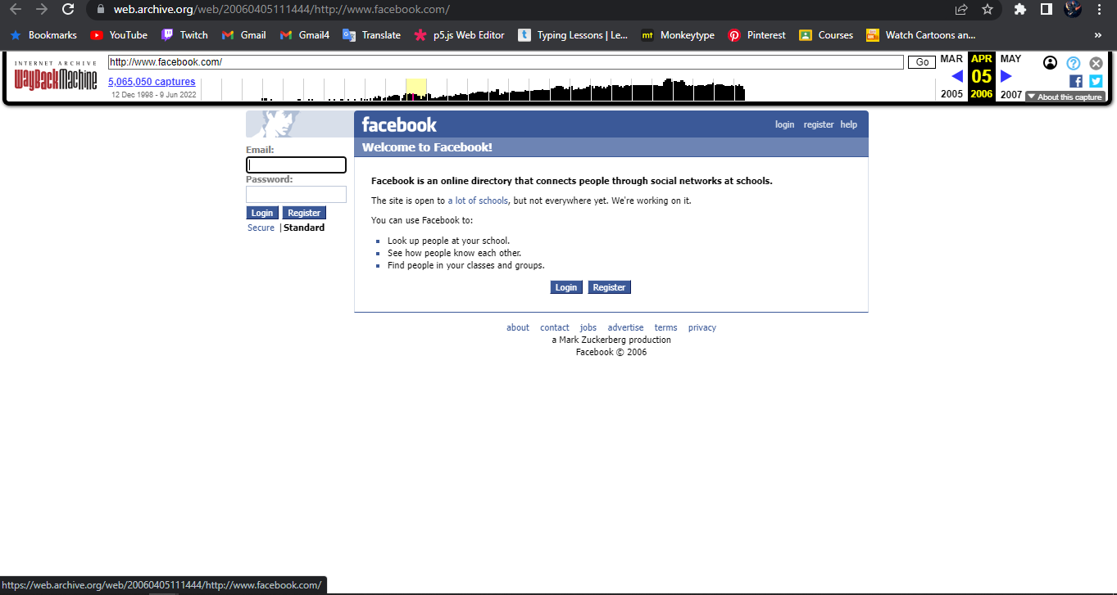

Facebook in 2010.

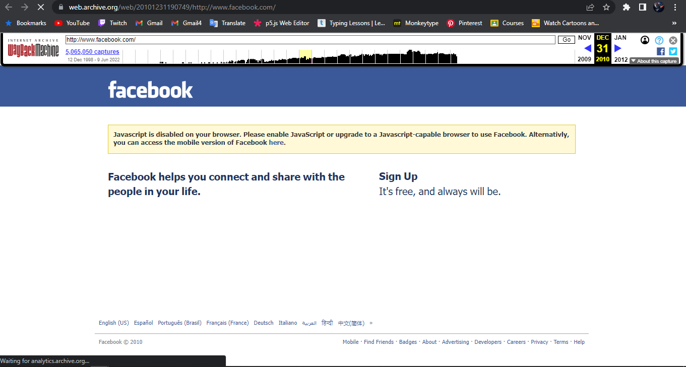

Facebook today.

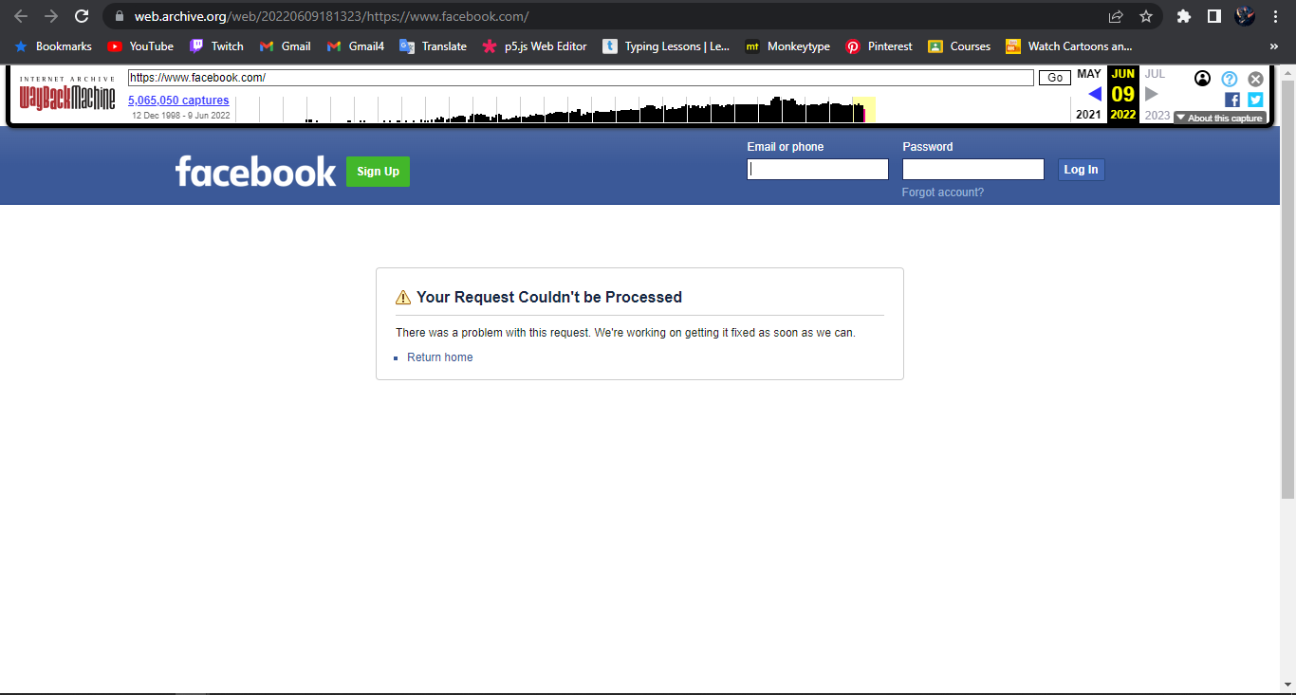

Facebook has greatly changed since its launch and greatly updated its patches.

From 2004, we can see that the updates that have been done on twitter.com are for the better of its users.